- Executive summary of the project:
Overview of Ceramic Industry:
The ceramic industry in Bangladesh dates back to 1962. People Ceramic Industries Ltd (PCI) pioneered the manufacture of porcelain tableware in Bangladesh. There are approximately 40 ceramic manufacturers operating in this industry producing tableware, sanitary ware and tiles. Shinepukur, Monno, Bengal Fine, Standard, Peoples and National Ceramic are considered as major players in ceramic tableware market. RAK, Fu Wang, China-Bangla, FARR, Modhumoti, ATI, Great Wall, Dhaka-Sanghai and Mir are major manufacturers of tiles and sanitary. The total capacity of ceramic tableware manufacturing companies is nearly 40,000 tones a year as of 2012, of which an average of 48 percent is exported and the remaining 52 percent is used in the domestic market. The Export Promotion Bureau (EPB) data showed that in the July-May period in FY 2012-13, the export earnings from ceramic goods amounted to almost $34.42 million with a 10 percent growth. Bangladesh exports ceramic products to about 50 countries including the US, the UK, Italy, Germany, France, Spain, Norway, Sweden, Turkey, Poland, Australia, New Zealand, Canada etc.
Local ceramic-ware manufacturing industry is expecting a steady growth with a US $100 million return from exports by 2015.

WHY DID WE CHOOSE TO WORK ON “CERAMIC INDUSTRY”?
- Foreign delegates frequently visit the market for exploring & purchasing our products. They go round the market to choose the designs, materials etc. of the products & to have conferences with the relevant companies.
- At present times, due to the political unrest, the business has become quite unstable and the foreign delegates cannot visit frequently in this situation.
- Moreover, in the modern world, people are more conscious about time. Almost all industries are now dependant on web based communication.
- So it is has become a necessity to develop a web platform that can represent our country’s ceramic market in front of the world.

2. Goals of the project:
- A “search filtering option” by which the buyers can search more precisely.
- Latest offers that the companies provide will be featured aside.
- Buyers can choose from the given designs of various companies and can also provide their own designs.
- Buyers can submit their requirements & the companies will offer their prices according to those requirements. As a result, the buyers can choose which company’s offer is more profitable for them.
- Local dealers can also purchase products via this website from industries.
- The basic information of the registered Ceramics showrooms of Bangladesh will be displayed so that buyers from country/ outside can contact them.

3. Project Platforms:
- HTML5
- CSS3
- PHP/ASP.NET
- JAVASCRIPT
- JQUERY
- MYSQL

4. Project current status: Raw project

5. Opportunities of Developments:
- We have to convince all industries to bring them under one platform as the market is highly competitive.
- As smart phones and tablet pc is growing faster we have to make our web application in such a way so that it should be more compatible for any device.
- The design of our website should be sleeker and more eye catching.
- As buyers have to visit Bangladesh, he/she have to worry for foods, hotels and travelling to industries. So our website might provide them the links of such things as well so he/she does not have to spend a lot of time for searching them.

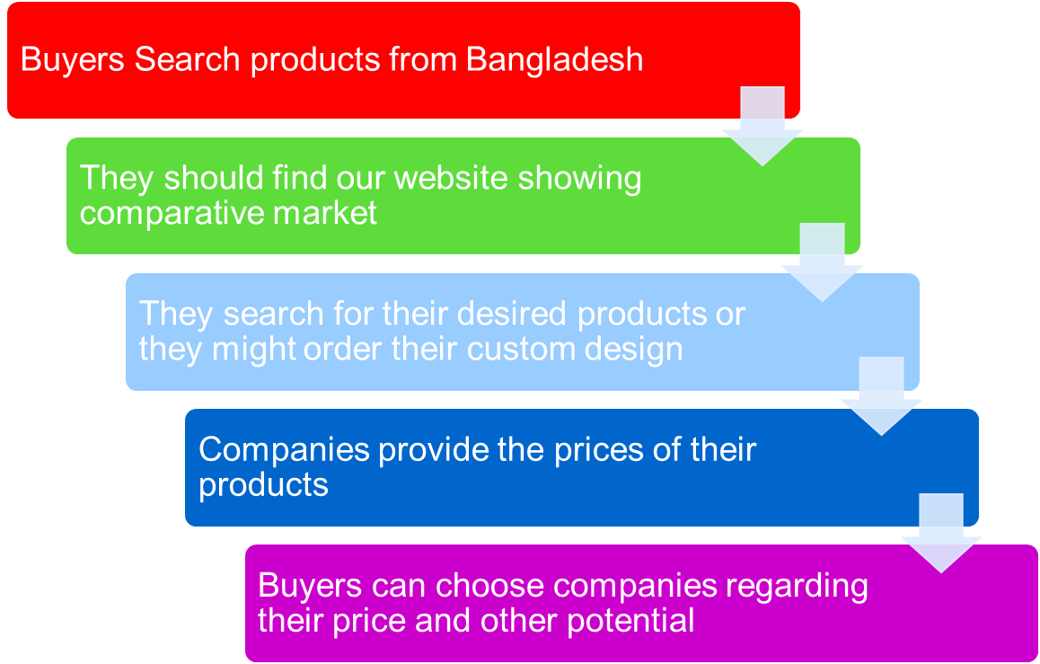
- 6. Flowchart:

***Thank you***

